The Bathtub Game Name ____________________________________________
Trial 1
Cycle | Players
0
1
2
3
4
5
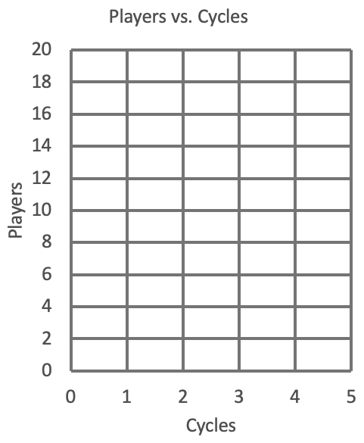
Start with ___ players
Five cycles of:
Inflow: ___ players in
Outflow: ___ players out

The stock of players ___ ____________________________________
Trial 2
Cycle | Players
0
1
2
3
4
5
Inflow vs. Outflow Lesson: ____________________________________ ______________________________________________________

Start with ___ players
Two cycles of:
Inflow: ___ players in
Outflow: ___ players out
Three cycles of:
Inflow: ___ players in
Outflow: ___ players out

The stock of players ___ ______________________________________________________
Inflow vs. Outflow Lesson: ____________________________________ ______________________________________________________
The Bathtub Game
Trial 3
Cycle | Players
0
1
2
3
4
5
Start with ___ players
Five cycles of:
Inflow: ___ players in
Outflow: ___ players out

The stock of players ___ ____________________________________
Trial 4
Cycle | Players
0
1
2
3
4
5
Inflow vs. Outflow Lesson: ____________________________________ ______________________________________________________

Start with ___ players
One cycle of:
Inflow: ___ players in
Outflow: ___ players out
One cycle of:
Inflow: ___ players in
Outflow: ___ players out
Three cycles of:
Inflow: ___ players in
Outflow: ___ players out

The stock of players ___ _________________________________________________________________
Inflow vs. Outflow Lesson: ____________________________________ ______________________________________________________

