Teamwork and Engineering Never Ends!
How did you work as a team to develop the best flying cups design and to invent a game using the flying cups? ________________
________________________________________________________________________________________________________________________________________________________________________________________________
If you were going to keep making your prototype better, what modifications would you make next and why? _____________ ________________________________________________________________________________________________________________________________________________________________________________________________________________________________
11
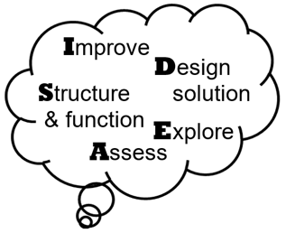
Flying Saucer Cups
Optimizing Flight Distance or Time

Engineer: ___________________________

Additional Engineering Team Member(s)
____________________________________
Designed by DaNel Hogan and Sherrie Dennis

More STEMAZing Sciencing and Engineering Journals,
like this one, can be found here:
https://stemazing.org/stemazing-sciencing-and-engineering-journals/
This work is licensed under a Creative Commons Attribution-NonCommercial-ShareAlike 4.0 Int’l License.

Flying Cups Original Design
Flight Distance or Flight Time
1
Which performance measure will you be optimizing? __________________________
What units will you use? _______________

Perform five launches of the Flying Cups original design you made and record the results below.
______ ______ ______ ______ ______
Trial 1 Trial 2 Trial 3 Trial 4 Trial 5

Circle the original design’s best performance trial above.
Let’s turn it into a game!
Game Logo
Game name _______________

Game Objective (how do you win/lose) __________ ________________________________________________________________________

Rules of the Game/Scoring Points/Winning ____________________________________ ____________________________________________________________________________________________________________________________________________________________________________________________________________________________________________________________

Diagram of Game Setup

10
Final (for now) Prototype
Describe all the form modifications you made to your prototype to optimize its form without impeding its performance. ________________________
________________________________________________________________________________________________________________________________________________________________________________________________
IDEAS for Function Modifications
2
9
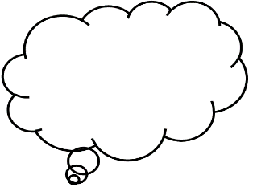
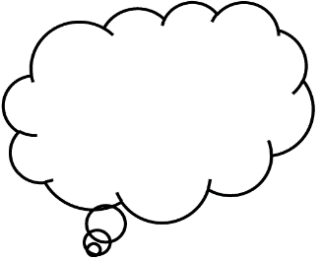
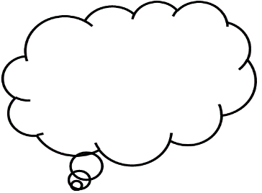
Can you make a part bigger/smaller?
Can you change the shape of a part?
Can you make a part lighter/heavier?
Are there different materials you could use?
Can you make a part longer/shorter?
Can you make a part wider/narrower?

Quick Prototype Modifications
(Fail fast, fail often!)
Describe Mod1: ______________________ ____________________________________
______ ______ ______ ______ ______
Trial 1 Trial 2 Trial 3 Trial 4 Trial 5
Circle best trial performance above.
Notes: ______________________________ ____________________________________
Mod1: Better or Boot (circle one)
IDEAS for Function Modifications
Can you add a part?
Did you notice something someone else tried that you could use?
Can you make a part stronger/weaker?
Will adding color make it more appealing?
Can the appearance be changed to make it more appealing?

Can you eliminate/replace a part?

Describe Mod2: ______________________ ____________________________________
______ ______ ______ ______ ______
Trial 1 Trial 2 Trial 3 Trial 4 Trial 5
Circle best trial performance above.
Notes: ______________________________ ____________________________________
Mod2: Keep or Kick (circle one)

Describe Mod3: ______________________ ____________________________________
______ ______ ______ ______ ______
Trial 1 Trial 2 Trial 3 Trial 4 Trial 5
Circle best trial performance above.
Notes: ______________________________ ____________________________________
Mod3: Better or Boot (circle one)
3
3
IDEAS for Form Modifications

Are there different materials you could use?
Can you make it sparkle?
Can you it make a cool noise?

Beyond a great performance, we also want a design that looks and sounds cool. Brainstorm ideas below about form modifications you could make to your current best prototype to improve its form or style.
________________________________________________________________ ________________________________________________________________ ________________________________________________________________
Try some of them out! As you make form modifications to your best prototype, be sure to check its performance to ensure it still works as well as it did before.
8
Best (so far) Prototype
4
7
Describe all the function modifications you made from the original design which optimized your flying cups best prototype performance.
________________________________________________________________________________________________________________________________________________________________________________________________________________________________________________________________________________________________________________________________________________________________________
Describe Mod4: ______________________ ____________________________________
______ ______ ______ ______ ______
Trial 1 Trial 2 Trial 3 Trial 4 Trial 5
Circle best trial performance above.
Notes: __________________________________ ________________________________________
Mod4: Keep or Kick (circle one)

Describe Mod5: _________________________ ______________________________________
______ ______ ______ ______ ______
Trial 1 Trial 2 Trial 3 Trial 4 Trial 5
Circle best trial performance above.
Notes: __________________________________ ________________________________________
Mod5: Better or Boot (circle one)

Describe Mod6: ______________________ ____________________________________
______ ______ ______ ______ ______
Trial 1 Trial 2 Trial 3 Trial 4 Trial 5
Circle best trial performance above.
Notes: __________________________________ ________________________________________
Mod6: Keep or Kick (circle one)
Describe Mod7: ______________________ ____________________________________
______ ______ ______ ______ ______
Trial 1 Trial 2 Trial 3 Trial 4 Trial 5
Circle best trial performance above.
Notes: __________________________________ ________________________________________
Mod7: Better or Boot (circle one)

Describe Mod8: _________________________ ______________________________________
______ ______ ______ ______ ______
Trial 1 Trial 2 Trial 3 Trial 4 Trial 5
Circle best trial performance above.
Notes: __________________________________ ________________________________________
Mod8: Keep or Kick (circle one)

Describe Mod9: ______________________ ____________________________________
______ ______ ______ ______ ______
Trial 1 Trial 2 Trial 3 Trial 4 Trial 5
Circle best trial performance above.
Notes: __________________________________ ________________________________________
Mod9: Better or Boot (circle one)
Additional Noticings, Wonderings, and Engineering Notes
6
5
________________________________________________________________________________________________________________________________________________________________________________________________________________________________________________________________________________________________________________________________________________________________________________________________________________________________________________________________________________________________________________________________________________________________________________________________________________________________________________________________

