Thinking more…
Now I wonder why… Now I wonder if… Now I wonder what…

Testable?

Now I wonder how… Now I wonder what would happen if…
Now I wonder ___________________ ____________________________________ _______________________________________________________________________.

Testable?

Now I wonder ___________________ ____________________________________ _______________________________________________________________________.

Testable?

Now I wonder ___________________ ____________________________________ _______________________________________________________________________.

Testable?

Now I wonder ___________________ ____________________________________ _______________________________________________________________________.

Testable?

Now I wonder ___________________ ____________________________________ _______________________________________________________________________.
15

Phenomenon
Questions
Research investigation
Science story
Thinking more

_______________________
Phenomenon

_______________________
Scientist’s Name

Basic Sciencing Journal
V4 – Average Bars with Data Points
DaNel Hogan – STEMAZing.org
Brooke Meyer – SARSEF.org
Sherrie Dennis – STEMAZing.org
Kristin Hunter-Thomson – dataspire.org

Draw and label Phenomenon

I notice ____________________________ ____________________________________ _______________________________________________________________________.

I notice ____________________________ ____________________________________ _______________________________________________________________________.

I notice ____________________________ ____________________________________ ___________________________________.
1
3. Reasoning (connect evidence to claim using scientific principles and rules) _________________ ________________________________________________________________________________________________________________________________________________________________________________________________________________________________________________________________________________________________________________________________________________________________________

Drawing to Explain Reasoning (Draw a model with labels to show what happens and why.)
Science Story (Using Claim, Evidence, and Reasoning, share the story the data tells and the science explains.)
14

2. Claim (answer to testable question, should either be one of you hypotheses or a new claim you had not considered) ____________________________ ________________________________________________________________________________________________________________________________________________

1. Evidence (cite data from the experiment to support the claim) ________________________ ________________________________________________________________________________________________________________________________________________________________________________________________________________________________________________________________________________________________________________________________________________________________________
2
13
Questions (or rather declarative wonders)
I wonder why… I wonder if… I wonder what…
I wonder how… I wonder what would happen if…

Testable?

I wonder ________________________
___________________________________________________________________________________________________________.

Testable?

I wonder ________________________
___________________________________________________________________________________________________________.

Testable?

I wonder ________________________

Testable?

___________________________________________________________________________________________________________.
I wonder ________________________

Testable?

___________________________________________________________________________________________________________.
I wonder ________________________
___________________________________________________________________________________________________________.
All Materials and Equipment Available
_________________ _________________
_________________ _________________
_________________ _________________
_________________ _________________
Data Talk (Notes from peer discussion about data observations, claim, evidence, and reasoning.)
____________________________________________________________________________________________________________________________________________________________________________________________________________________________________________________________________________________________________________________________________________________________________________________________________________________________________________________________________________________________________________________________________________________________________________________________

_________________ _________________
_________________ _________________
_________________ _________________

Play to learn more – tinker and experiment with materials and equipment you have available to explore how everything works. Continue observing the phenomenon, noticing, and wondering.

I notice ____________________________ ____________________________________ _______________________________________________________________________.
I notice ____________________________ ____________________________________ _______________________________________________________________________. I notice ____________________________ ____________________________________ _______________________________________________________________________.
12
3
Even More Wonderings
Data Observations (What do you notice as you look at the raw data collected in the data table and at the graphical representation of the data?)
________________________________________________________________________________________________________________________________________________________________________________________________________________________________________________________________________________________________________________________________________________________________________________________________________________________________________________________________________________________________________________________________________

Now I wonder why… Now I wonder if… Now I wonder what…

Testable?

Now I wonder how… Now I wonder what would happen if…
Now I wonder ___________________ ____________________________________ ___________________________________.

Testable?

Now I wonder ___________________ ____________________________________ ___________________________________.

Testable?

Now I wonder ___________________ ____________________________________ ___________________________________.
11
4
Brainstorm Break
What can I change that might impact how the phenomenon works? (cause)
____________________________________________________________________________________________________________

What can I measure about the phenomenon that might be different when I setup the experiment differently using one of my ideas above? (effect)
____________________________________________________________________________________________________________
What do I want to test?
Independent variable ______________________
Option 1 ____________ Option 2 ____________

Testable Question (can be answered with a claim based on evidence from a scientific experiment)

How will changing ____________________
independent variable (what I manipulate – cause)

affect ______________________________?
__________________________________ __________________________________
Option 1 Option 2
_____________________________________________
Independent Variable (units)
dependent variable (what I measure as the outcome – effect)
________________________________________________________
Dependent Variable Name vs. Independent Variable Name

Multiple Hypotheses (consider every possible claim you might be able to make once you collect data)

Hypothesis/Prediction A: Yes, ____________ ________________________________________________________________.
Hypothesis/Prediction B: Yes, ____________ ________________________________________________________________.

Hypothesis/Prediction C: No, ____________ ________________________________________________________________.
_______________________________________
Dependent Variable Name (units)
5
5
10

___________________  10  Dependent Variable Name (units) | Option 2
 | Option 1
__________  Independent Variable Name (units) |  | Trial 1 | Trial 2 | Trial 3 | Trial 4 | Trial 5 | Average

Data Prediction for Each Hypothesis
6
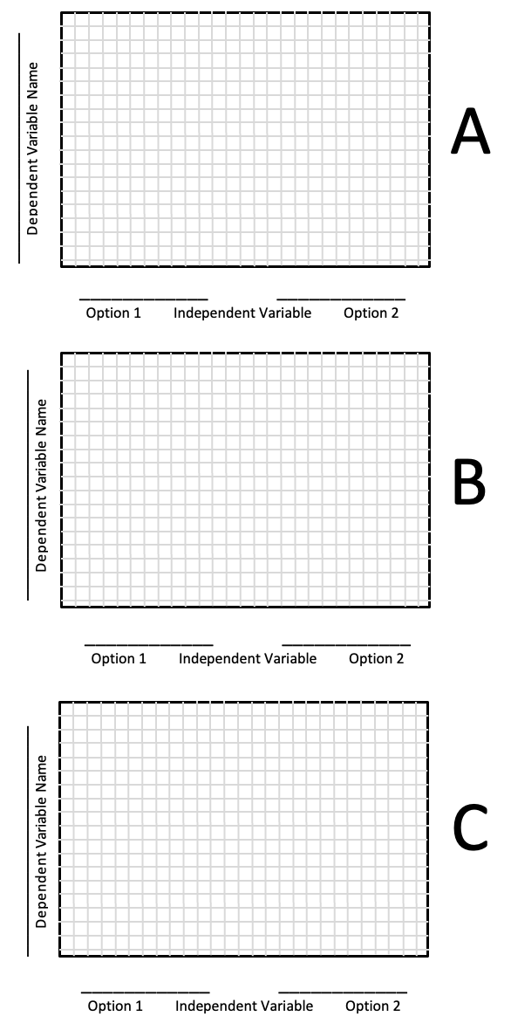
9

Research Investigation (Experiment)
Draw and label experimental setup.

Materials and Equipment List for Experiment
________________________________________________________________________________________________________________________________________________________________________________________________________________________________________________________________________________________________________________________________________________________________________
7
Experimental Procedure (detailed enough to allow data collection to be repeated exactly as you collected it)

NOTE: Control Variables (all independent variables not selected for testing must be given a set value or controlled. These controlled settings must be explicitly noted in the procedure.)
8
________________________________________________________________________________________________________________________________________________________________________________________________________________________________________________________________________________________________________________________________________________________________________________________________________________________________________________________________________________________________________________________________________________________________________________________________________________________________________________________________________________________________________________________________________________
11

