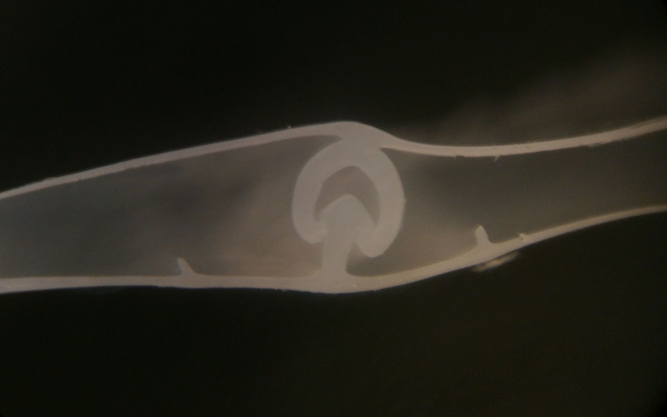Name: ___________________________________________
It’s (zipped) In The Bag
INVESTIGATE

- Look at the three different types of bags

How are they similar? | How are they different?

Draw and Label a picture of how the baggie sealing mechanism works:

EXPLORE
What will you design to hold a file folder closed but still be able to be opened? Draw and label your idea.

EXPLAIN
- Write an explanation. How does your mechanism hold the two sides of the folder together? What forces do you think are at work.
________________________________________________________________________________________________________________________________________________________________________________________________________________________________________________________________________________________________________________________________
- Draw what you actually built. Use arrows to label the forces involved.

- Describe how your mechanism is similar to and different from the baggies we investigated with.
________________________________________________________________________________________________________________________________________________________________________________________________________________________________________________________________________________________________________________________________
- Have you made a single, double, or multitrack sealing mechanism?
________________________________________________________________________________________________________________________________

EXTEND
Investigate the zipper style bag
- How is this similar to and different from the other baggies?

How are they similar? | How are they different?

- Describe what the slider does as you move it back and forth.
______________________________________________________________________________________________________________________________________________________________________________________________________________________________________________________________________________________________________________________________________________________________

- Make a sketch of how the zipper works.

EVALUATE
- Select one idea - the zipper, the sealable plastic fasteners, or your own sealing device - and invent a new use for that mechanism. Write an explanation of your innovation.
__________________________________________________________________________________________________________________________________________________________________________________________________________________________________________________________________________________________________________________________________________________________________________________________________________________________________________________________________________________________________________

